




Bopinc

Personal Care Dispenser Manual

Version 1.0
05 December 2022

Contents

Contents 2
Background 3
Dispenser Overview 3
Power supply 3
Measurements and Key Components 3
Dispensing Accuracy 5
Product Quality Assurances 5
Usage 5
Stock replenishment 7
Troubleshooting 8

Background
The refill dispenser is an electronic machine that dispenses viscous liquid personal care products such as shampoo. Consumers use the machine to fill empty, reusable containers with product from the dispenser. The objective of the dispenser is to encourage shoppers to reduce the purchasing and use of personal care products in small plastic sachets which have become an environmental problem.

Dispenser Overview

Power supply
Electricity is required for the electronic refill dispenser to operate. There is no on/off switch for the dispenser and it automatically turns on once connected to a power supply, and off when there is no power supply. The machine is indicated as being on when the LCD screens show text and intermittently flash with light.

The dispenser has a standard cable and plug that plugs into the main grid electricity supply. In the case of brief periods of electricity loss, there is a battery that is able to power the dispenser for up to 4 hours of continual motor use, and it is charged by the main power supply.

Measurements and Key Components
Front view
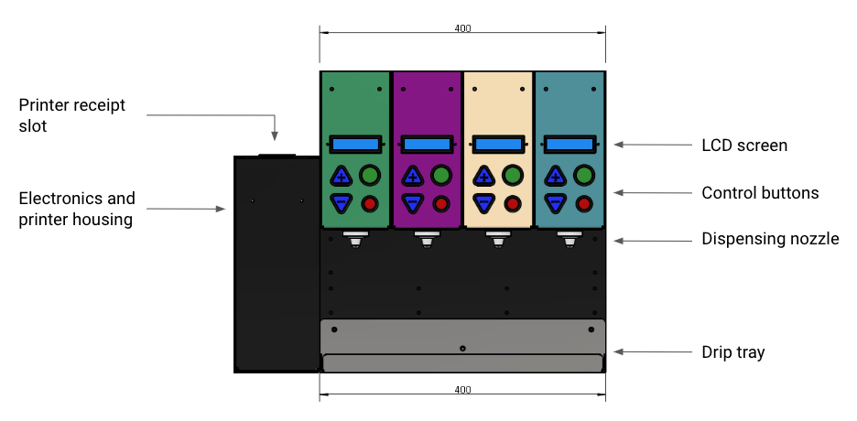

Side view
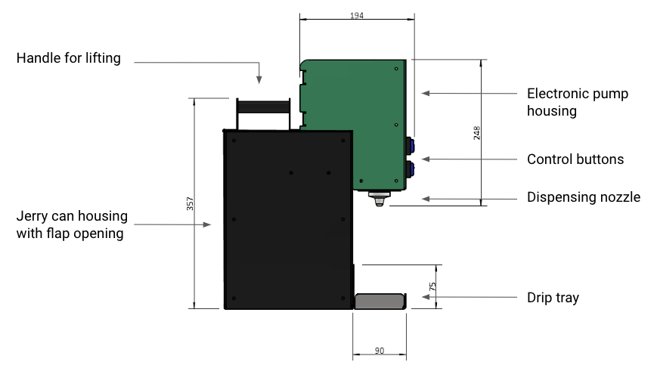

Internal view
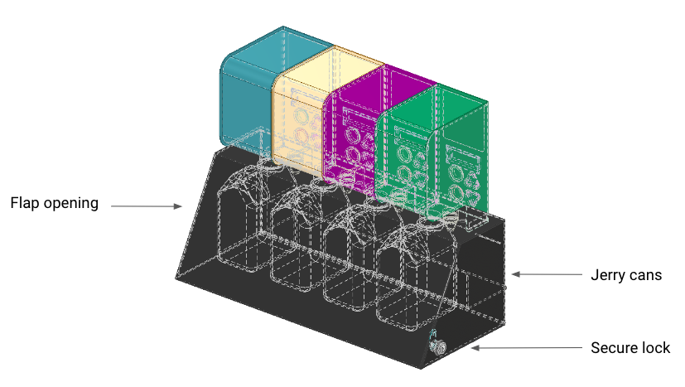

Dispensing Accuracy
Because of the small quantities dispensed by the machine, the refill station is very accurate with an error margin of less than 3%. Any error will be positive (i.e. more product dispensed rather than less), so the customer gets at least the quantity they select.

Product Quality Assurances
Product quality is maintained in 4 ways:
- Jerry cans are securely contained within the dispenser itself, and access to the jerry cans are protected by lock and key. Only approved Unilever contacts have a key and are able to gain access to the jerry cans to protect the product from being tampered with.
- Jerry cans are not exposed to UV as they are secured within the dispenser.
- To avoid any microbial contamination or degradation of the product itself, the dispenser can only dispense product from the jerry cans, product cannot be reversed back into the machine or jerry cans.
- To minimise product contact with air as well as unintentional dripping of the product, the dispenser nozzle contains a seal closure that shuts when the machine stops dispensing.

Usage
To use the machine, a consumer will use a reusable, empty plastic container that can be filled with the product, used at home, and washed once empty to refill again.
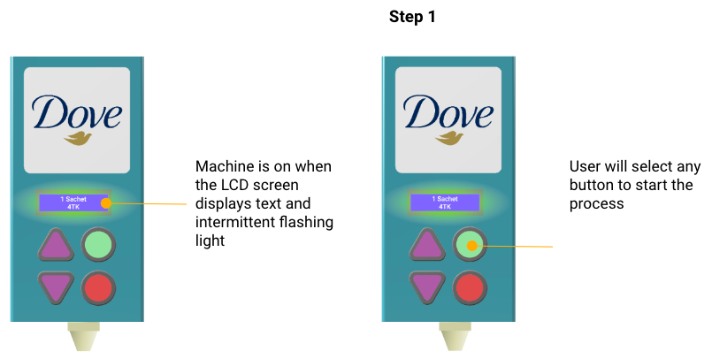
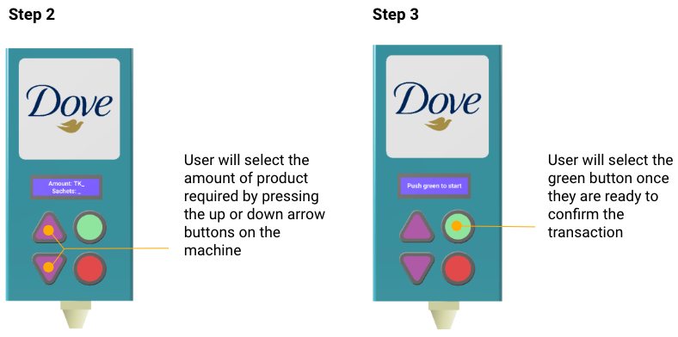

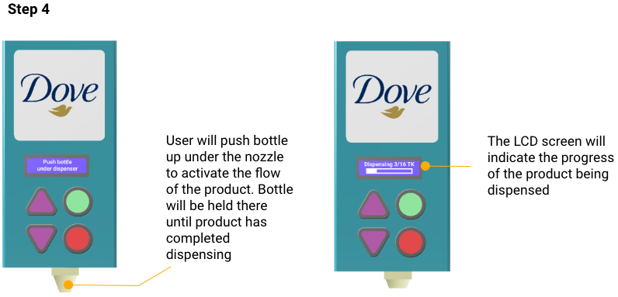
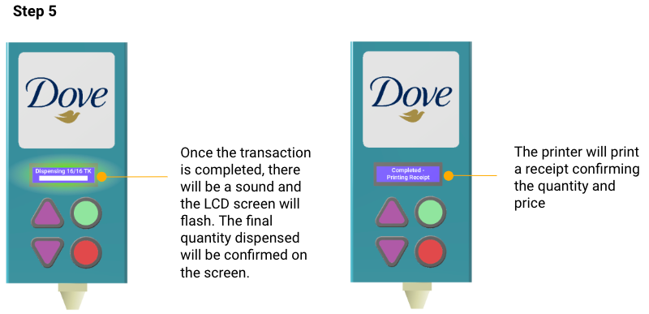

Stock replenishment
Unilever brand representatives are responsible for replenishing empty jerry cans, and will have a key to unlock the refill dispenser to gain access to replenish jerry cans.

Product stock levels are monitored via cloud software where weekly stock and usage reports will be circulated with Bopinc and Wizkit teams. Jerry cans with low stock levels will be flagged by the software, and teams can notify Unilever to order and facilitate replenishment of that machine and product.

The process to replenish empty jerry cans is as follows:
- Authorised persons will unlock the dispenser opening with a key and lifting the back flap to gain access to the jerry cans
- The lid of the jerry can will be unscrewed, and the jerry can removed from the dispenser housing
- The tube and nozzle of the product being replenished will undergo cleaning as per Unilever requirements
- The lid of the new, full jerry can will be removed, the dispenser tube will be placed into the new jerry can and the attached cap will be screwed on
- The jerry can will be placed securely within the dispenser housing
- The housing flap will be closed and the lock secured with a key

Troubleshooting
If the dispenser stops working, the retailer can notify Unilever who will contact their technical partner, Wizkit, to troubleshoot the machine on site. The machine can be replaced with a back-up machine if any issues cannot be immediately resolved, and the broken dispenser can be repaired as needed offsite.

